Travel Request

Blank In-County Travel Authorization Form
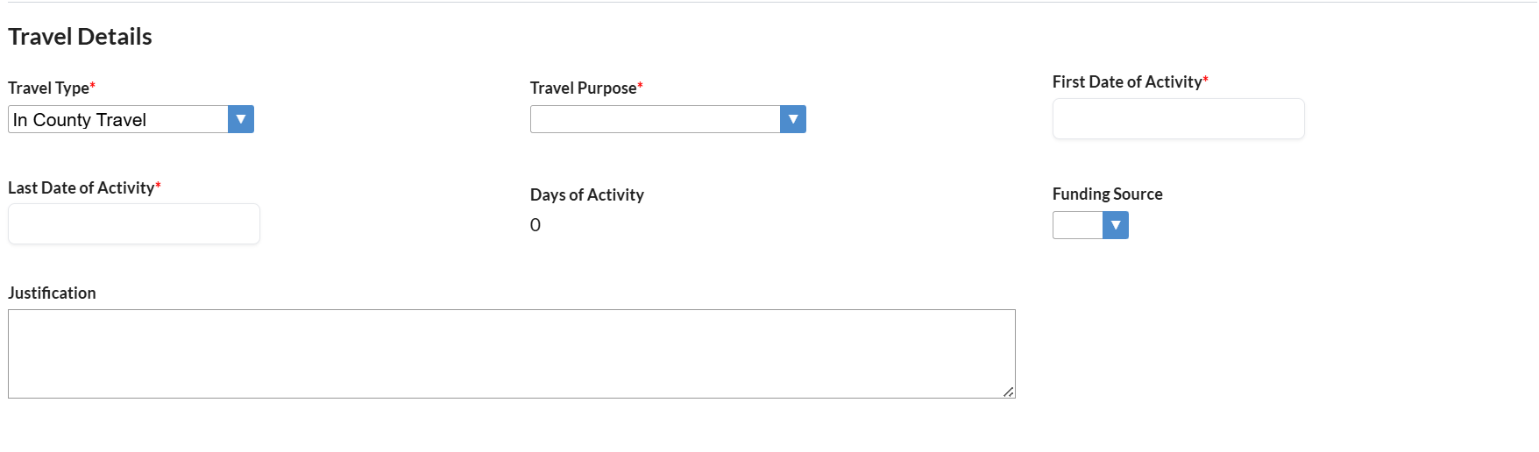
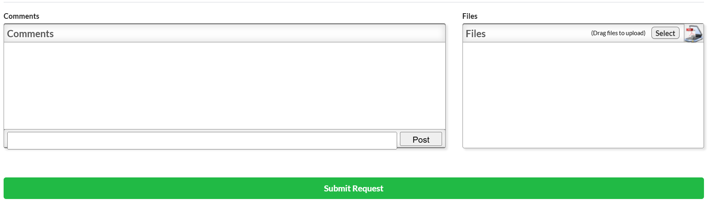

Submitting an In-County Travel Authorization Request
- Step 1: Navigate to Employee Self Service > Employee Requests > Travel Authorization
- Step 2: Pick ‘Travel Type’ of In County Travel in drop down
- Step 3: Select ‘Travel Purpose’ in drop down
- Step 4: Enter ‘First Date of Activity’ by using the calendar prompt
- Step 5: Enter ‘Last Date of Activity’ by using the calendar prompt
- Step 6: Enter ‘Justification’ in Text Box
- Step 7: To enter comment into ‘Comments’ box - Type comment and click on ‘Post’
- Step 8: To upload a file into the ‘Files’ box - Drag and Drop file or Select to open File prompt or press the Scan button to scan document
- Step 9: Click ‘Submit Request’ green button
- Step 10: Click OK or Cancel to return back to form

Blank Out-of-County or Out-of-State Travel Authorization Form
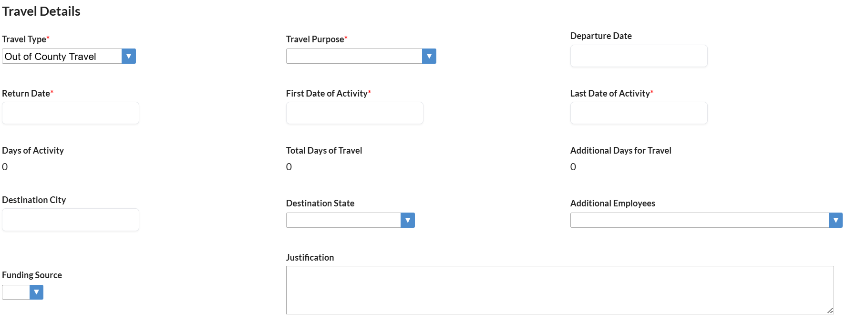
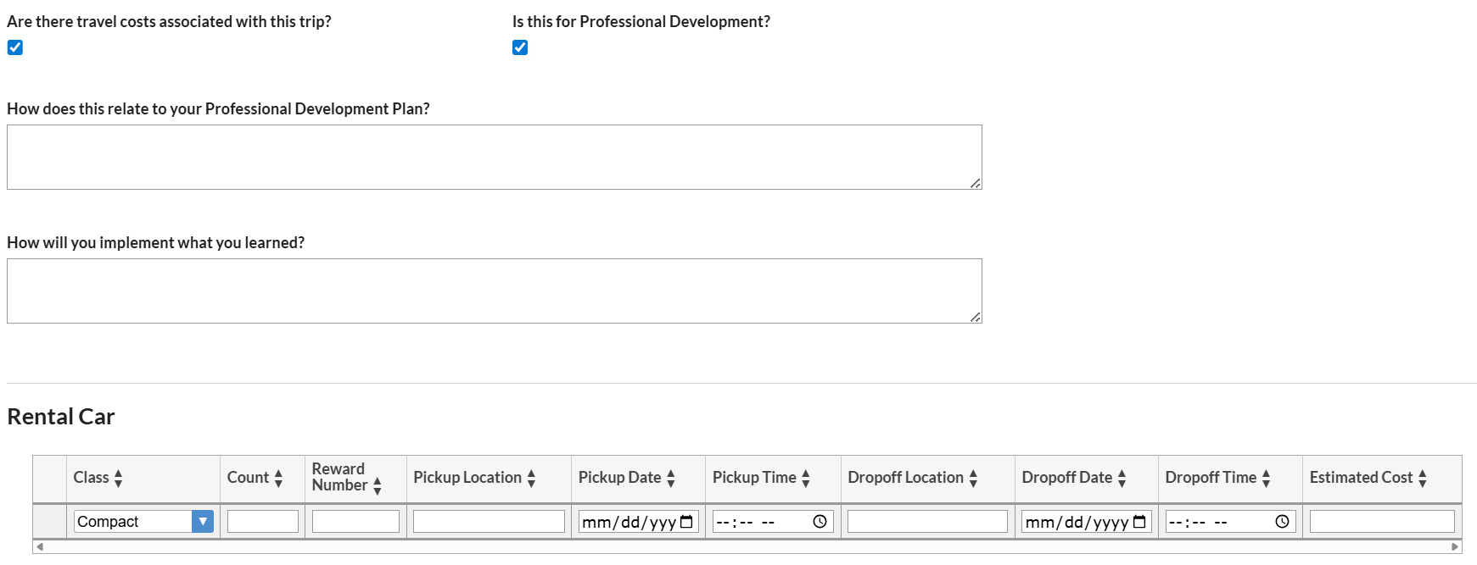
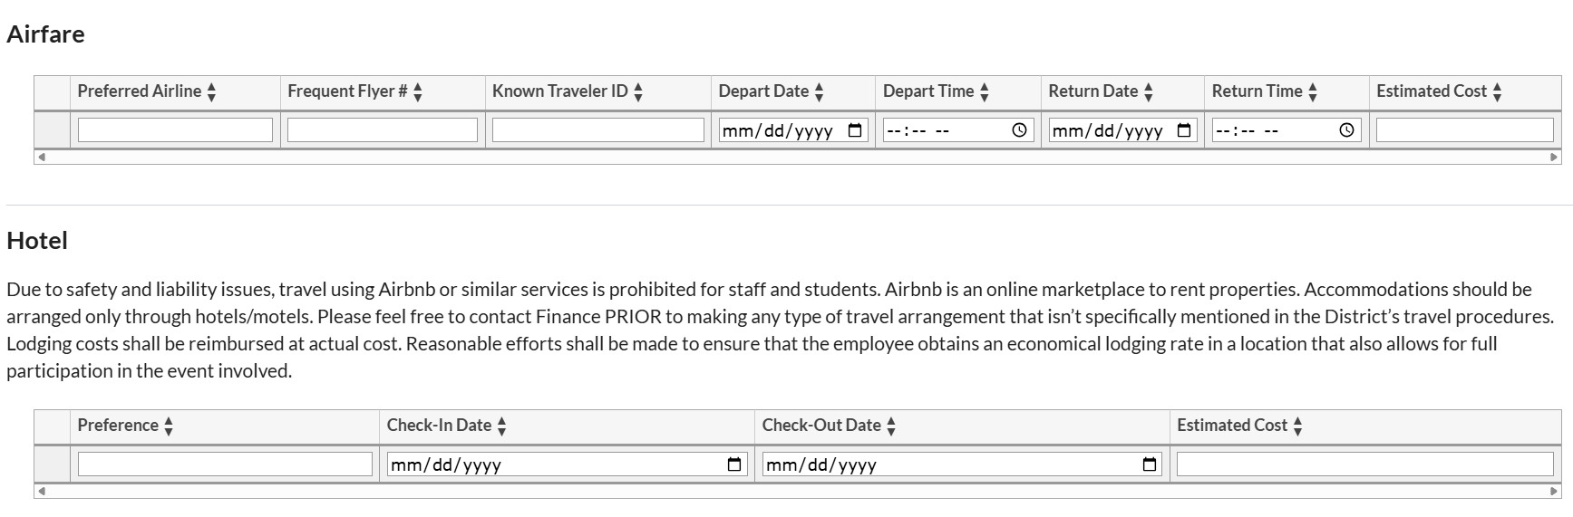
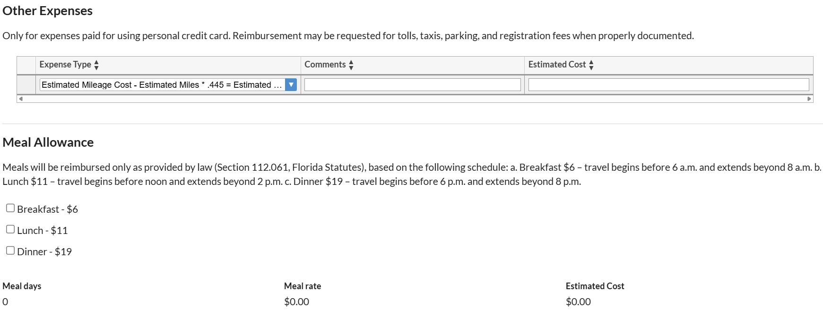
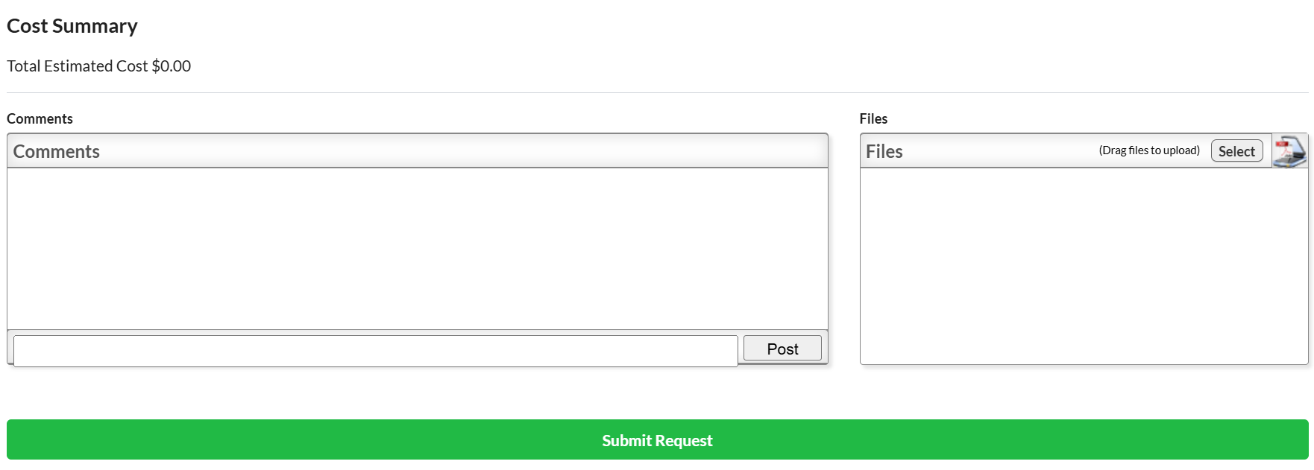

Submitting Out-of-County or Out-of-State Travel Authorization Request
- Step 1: Navigate to Employee Self Service > Employee Requests > Travel Authorization
- Step 2: Pick ‘Travel Type’ – either Out-of-County Travel or Out- in drop down
- Step 3: Select ‘Travel Purpose’ in drop down
- Step 4: Enter ‘Departure Date’ by using the calendar prompt
- Step 5: Enter ‘Return Date’ by using the calendar prompt
- Step 6: Enter ‘First Date of Activity’ by using the calendar prompt
- Step 7: Enter ‘Last Date of Activity’ by using the calendar prompt
- Step 8: Enter ‘Destination City’ in text box
- Step 9: Select ‘Destination State’ in drop down
- Step 10: Enter ‘Justification’ in Text Box
- Step 11: Select ‘Are there travel costs associated with this trip?’ to open additional options - Do not select if there are no travel costs associated with the trip.
- Step 12: Select ‘Is this for Professional Development?’ to open additional text boxes
  - Answer ‘How does this relate to your Professional Development Plan?’ in text box
  - Answer ‘How will you implement what you learned?’ in text box
- Step 13: If a rental car is needed - Select Class from drop-down, and enter Estimated Cost in the ‘Rental Car’ section.
  - Additional information can be provided: Count, Reward Number, Pickup Location, Pickup Date, Pickup Time, Dropoff Location, Dropoff Date, Dropoff Time, otherwise can be left blank
- Step 14: Press the Enter/Return key to save the line of data.
- Step 15: Enter as many rental car requests as needed.
- Step 16: You can edit the fields by clicking the applicable field. Once changes are made, edits are automatically saved.
- Step 17: Click the Delete button (red minus sign) to delete a rental car.
- Step 18: If airfare is needed - Enter Estimated Cost in the ‘Airfare’ section.
  - Additional information can be provided: Preferred Airline, Frequent Flyer #, Known Traveler ID, Depart Date, Depart Time, Return Date, Return Time, otherwise can be left blank
- Step 19: Press the Enter/Return key to save the line of data.
- Step 20: Enter as many airfare requests as needed.
- Step 21: You can edit the fields by clicking the applicable field. Once changes are made, edits are automatically saved.
- Step 22: Click the Delete button (red minus sign) to delete an airfare.
- Step 23: If other transportation is needed - Select Transportation Type from drop-down, and enter Estimated Cost in the ‘Other Transportation’ section.
- Step 24: Press the Enter/Return key to save the line of data.
- Step 25: Enter as many other transportations as needed.
- Step 26: You can edit the fields by clicking the applicable field. Once changes are made, edits are automatically saved.
- Step 27: Click the Delete button (red minus sign) to delete other transportations.
- Step 28: If a hotel is needed - Enter Estimated Cost in the ‘Hotel’ section.
  - Additional information can be provided: Preference, Check-in Date, Check-out Date, otherwise can be left blank
- Step 29: Press the Enter/Return key to save the line of data.
- Step 30: Enter as many hotels as needed.
- Step 31: You can edit fields by clicking the applicable field. Once changes are made, edits are automatically saved.
- Step 32: Click the Delete button (red minus sign) to delete a hotel.
- Step 33: If other expenses are needed - Select Expense Type from drop down and enter Estimated Cost in the ‘Other Expense’ section.
Estimated Mileage Cost can be input here to include in
  - Additional information can be provided: Comments, otherwise can be left blank
- Step 34: Press the Enter/Return key to save the line of data.
- Step 35: Enter as many other expenses as needed.
- Step 36: You can edit fields by clicking the applicable field. Once changes are made, edits are automatically saved.
- Step 37: Click the Delete button (red minus sign) to delete other expenses.
- Step 38: If Meal Allowance is needed - Select which meal is needed in the ‘Meal Allowance’ section.
  - Estimated Cost will be calculated based on selections
- Step 39: Cost Summary section will add all the Estimated Cost from each section.
- Step 40: To enter comment into ‘Comments’ box - Type comment and click on ‘Post’
- Step 41: To upload a file into the ‘Files’ box - Drag and Drop file or Select to open File prompt or press the Scan button to scan document
- Step 42: Click ‘Submit Request’ green button
- Step 43: Click OK or Cancel to return back to form

Review status of Travel Authorization Request
- Step 1: Navigate to Employee Self Service > Employee Requests > History
- Step 2: Hover over Status column

Make changes to Submitted Travel Authorization Request
  - Step 1: Navigate to Employee Self Service > Employee Requests > History
  - Step 2: Click on View
  - Step 3: Scroll to the bottom
  - Step 4: Click on Return to Draft

Cancel Travel Authorization Request
- Step 1: Navigate to Employee Self Service > Employee Requests > History
- Step 2: Click on View
- Step 3: Scroll to the bottom
- Step 4: Click on Cancel Request

Duplicate Travel Authorization Request
- Step 1: Navigate to Employee Self Service > Employee Requests > History
- Step 2: Click on View
- Step 3: Scroll to the bottom
- Step 4: Click on Duplicate button

